Firebrand flux

186 m

0 m

320 m

FBP X

FBP Y

FBP Z

FCS X

FCS Y

FCS Z

Fire line

Road

320 m

160 m

300 m

250 m

150 m

100 m

50 m

Forest fire simulations

Wind field development

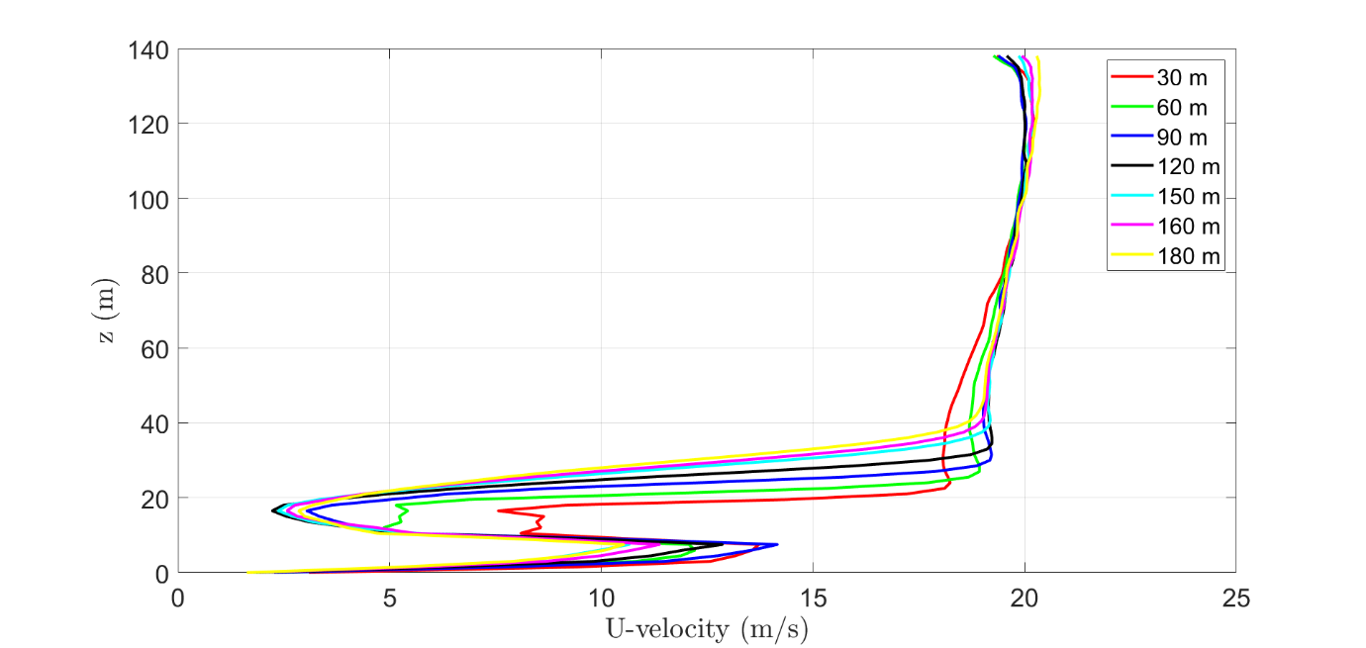

Note: Fire has been started(at 120 s). Particle inputting has been started(at 130 s). Current simulation time is 141 s.

Collection time span (s)

FCS X – 407 s

FCS Y – 513 s

FCS Z – 394 s

|  |  |  |  |  |  |  |  |  |  |
| --- | --- | --- | --- | --- | --- | --- | --- | --- | --- |
| Case | Wind velocity  (m/s) | Particle velocity  (U,V,W) m/s | Input rate pcs/s | **Flux (pcs/m2. s)** | | | **Number of Firebrands(pcs)** | | |
| FCS Z | FCS Y | FCS X | FCS Z | FCS Y | FCS X |
| T H- grid(1.5 m) | ≈2.0 | (8.3, 0.0, 2.1) | 11006 | 1.465 | 1.302 | 0.701 | 577 | 668 | 285 |
| T valid- grid(0.75 m) | ≈2.2 | (8.3, 0.0, 2.1) | 11006 | 1.962 | 0.921 | 0.793 | 773 | 472 | 323 |
| Experiment | 1.4±0.6 | NA | NA | 1.361 | 0.902 | 0.824 | 536 | 463 | 335 |
| Difference(%)  (Exp /T valid) |  |  |  | 30.6% | 02.1% | -03.9% | 30.6% | 02.1% | -03.6% |







Heat release rate(MW) and Mass loss rate(kg/s)

|  |  |  |  |
| --- | --- | --- | --- |
| **AS3959 fuels** |  |  | Ponderosa pine |
| Eucalyptus | Pitch pine | Douglas fir | Grand fir |
|  |  |  | Saw Palmetto |
| Acacia | Western Juniper | Loblolly pine | Chamise |
|  |  |  | Leyland Cypress |
| Banksia | Sage brush |  | Little blue stem |

Red colour: effect of MC relationships

Green colour: effect of species relation ships

Blue colour: effect of wind speed relationship

Violet colour: Similar trees in terms of height, physical appearance( foliage, branching form and size, location and soil etc.

Parameters for AS3959 work

|  |  |  |  |  |  |  |  |  |  |  |  |
| --- | --- | --- | --- | --- | --- | --- | --- | --- | --- | --- | --- |
| **Parameter** | | | | | | | **Value** | | | **Description** | |
| Ambient temperature (0C) | | | | | | | 39 | | | Similar to grass fire simulation[ref] | |
| Relative humidity (%) | | | | | | | 25 | | | Similar to grass fire simulation[ref] | |
| Wind velocity at the Fireline (m/s) | | | | | | | 11.11 [40 km/h] | | | Tweak to obtain FDI 50, 80 and 100 in AS3959-2018 | |
| 16.67 [60 km/h] | | |
| 19.44 [70 km/h] | | |
| Forest fuel  Length/diameter  (needles)(mm) | | Type1: Eucalyptus  Type 2:Banksia  Type 3: Acasia | | | | | L=10 dmax= 6.35  L=10 dmax= 6.35  L=10 dmax= 6.35 | | |  | |
| Fuel moisture(%) | | surface | | | | | 3.84 | | | Eqn 2.58 Fire behaviour knowledge in Australia (Cruz et al) | |
| canopy | | | | | 3.84 | | |
| Fuel mass per volume (kg/m2) | Forest | over storey | | | | | 0.1 | | | AS3959-2018  Table B3:Vegetation classification and fuel load. | |
| under storey | | | | | 2.5 | | |
| Scrub | over storey | | | | | 0.0 | | |
| under storey | | | | | 2.5 | | |
| Mallee/Mulga | over storey | | | | | 0.0 | | |
| under storey | | | | | 0.8 | | |
| Drag law for static fuel | | | | | | | Haider and Levenspiel model. | | | The modified FDS 6.6.0 code will be used and it has drag law calculations according to firebrands shapes(sphere, cylinder, cubic) | |
| Canopy height max (m) | | | Forest | | | | 40 | | | AS3959-2018  Table B3:Vegetation classification and fuel load, Table 2.3 | |
| Scrub | | | | 3 | | |
| Mallee/Mulga | | | | 3 | | |
| Under storey height min (m) | | | Forest | | | | 10 | | | AS3959-2018-Fig. 2.4 (B), 2.4 (E), 2.4(F) | |
| Scrub | | | | 0 | | |
| Mallee/Mulga | | | | 0 | | |
| Firebrands  (classified into 22 types of cylindrical shape, 13 types of cubic shape and 7 types of spherical shape firebrands) | | Cylindrical shape, dimensions  (cm)  (length/diameter) | | | | | Fbcy1 | 0.877 | 0.236 | | Taken from Investigation of firebrand production during prescribed fire: Filkov et al Combustion institute 2017 and processed. |
| Fbcy2 | 1.010 | 0.282 | |
| Fbcy3 | 0.933 | 0.266 | |
| Fbcy4 | 1.044 | 0.209 | |
| Fbcy5 | 1.059 | 0.284 | |
| Fbcy6 | 6.108 | 1.412 | |
| Fbcy7 | 3.166 | 0.850 | |
| Fbcy8 | 3.333 | 0.817 | |
| Fbcy9 | 3.426 | 0.922 | |
| Fbcy10 | 2.297 | 0.593 | |
| Fbcy11 | 2.557 | 0.623 | |
| Fbcy12 | 3.411 | 0.583 | |
| Fbcy13 | 2.230 | 0.529 | |
| Fbcy14 | 1.819 | 0.408 | |
| Fbcy15 | 2.689 | 0.285 | |
| Fbcy16 | 9.130 | 1.222 | |
| Fbcy17 | 6.250 | 0.290 | |
| Fbcy18 | 4.780 | 0.140 | |
| Fbcy19 | 3.343 | 0.303 | |
| Fbcy20 | 6.444 | 0.380 | |
| Fbcy21 | 3.395 | 0.125 | |
| Fbcy22 | 3.350 | 0.435 | |
| Cubic shape, dimensions  (cm)  (Width/ Length) | | | | | Fbcu1 | 0.808 | 0.574 | |
| Fbcu2 | 0.852 | 0.545 | |
| Fbcu3 | 0.826 | 0.543 | |
| Fbcu4 | 0.962 | 0.658 | |
| Fbcu5 | 3.671 | 2.326 | |
| Fbcu6 | 2.012 | 1.460 | |
| Fbcu7 | 1.915 | 1.384 | |
| Fbcu8 | 2.307 | 1.465 | |
| Fbcu9 | 1.520 | 0.975 | |
| Fbcu10 | 1.465 | 0.968 | |
| Fbcu11 | 1.384 | 0.919 | |
| Fbcu12 | 1.403 | 0.851 | |
| Fbcu13 | 1.167 | 0.861 | |
| Spherical shape, dimensions  (cm)(Radius) | | | | | Fbs1 | 0.351 |  | |
| Fbs2 | 0.289 |  | |
| Fbs3 | 1.566 |  | |
| Fbs4 | 0.861 |  | |
| Fbs5 | 0.764 |  | |
| Fbs6 | 0.667 |  | |
| Fbs7 | 0.528 |  | |
| Drag laws | | | | | Use Haider and Levenspiel drag models. | | | FDS 6.6.0-modified version will be modified to insert the drag model to the source code.  The drag coefficient over-rides the drag law. | |
| Density (kg/m3) | | | | | 354 | | | Taken and calculated from Muller et al. | |
| Initial temperature (0C) | | | | | 411 | | | Whadhwani et al. | |
| Fireline  (static) | | Length (m) | | | | | 100 | | | AS3959 and New Jersey prescribed fire Filkov et al 2016. | |
| Depth (m) | | | | | 2 | | |
| Magnitude (kW/m) | | Forest | | FDI50 | 23184.45 | | | Calculated based on the equations in Fire behaviour Knowledge -Cruz et al and AS3959-2018:Table B4, equations B1, B2. | |
| FDI80 | 37020.87 | | |
| FDI100 | 46781.22 | | |
| Scrub | | FDI50 | 59158.23 | | |
| FDI80 | 96624.13 | | |
| FDI100 | 116437.1 | | |
| Mallee/  Mulga | | FDI50 | 18930.63 | | |
| FDI80 | 30919.72 | | |
| FDI100 | 37259.86 | | |
| Tree trunks | | Height (m) | | | Eucalyptus | | 25 | | | Calculated based on the NJ pitch pine tree trunk height and canopy height. | |
| Banksia | | 1.8 | | |
| Acacia | | 1.8 | | |
| number | | | | | ** | | | Represented by non-burning obstacles. | |
| spreading | | | | | - | | | randomly | |
| Domain | | 1.5 m and, 750 mm grid sizes | | | | | 276mx102m x138 m | | |  | |